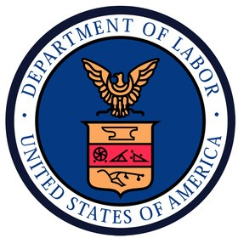
1/12, 1/19, and
1/26 at 3 PM
1/23 at 11 AM

1/9 and 1/30 at 11 AM
101 Station Landing, Fourth Floor Medford, MA
450 Summer Street
(Omni Boston Hotel at the Seaport)
Boston, MA

https://us02web.zoom.us/j/87674861519
For directions, please visit www.besthtc.org/contact-us/
BEST Hospitality Training
101 Station Landing, Fourth Floor • Medford, MA 02155
450 Summer Street (Omni Boston Hotel at the Seaport) • Boston, MA 02210 (617) 542-1177 • www.BESThtc.org

Next class starts March 3, 2023
Start Your Hotel Career
Introduction to Hospitality Housekeeping Pre-Apprenticeship Program
Free training
prepares graduates for union hotel housekeeping jobs at Boston
area hotels
TO APPLY:
VISIT OUR WEBSITE  www.besthtc.org/pre-apprenticeship-apprenticeship-programs/  ATTEND AN IN-PERSON INFO SESSION |  |  |  |  | Training is six weeks  Monday to Friday - 9AM to 2PM Class is hybrid: in-person and online  Most jobs pay at least $25/hour to start  Generous benefits package Earn up to 12 college credits at  Bunker Hill Community College
 | AT | TEND A VIRTUAL INFO SESSION
 |  |  |  | This program is supported by:

